Experiment -6
E-Commerce Website — UI Wireframe Document
Name : RAGHURAM
reg no : 240701812

Flow 1: User Registration & Login

This flow covers how users authenticate — sign in for returning users and account creation for new users.

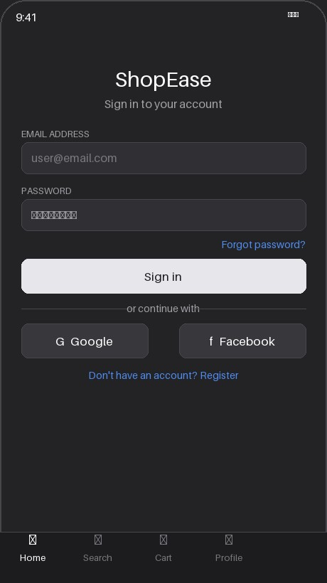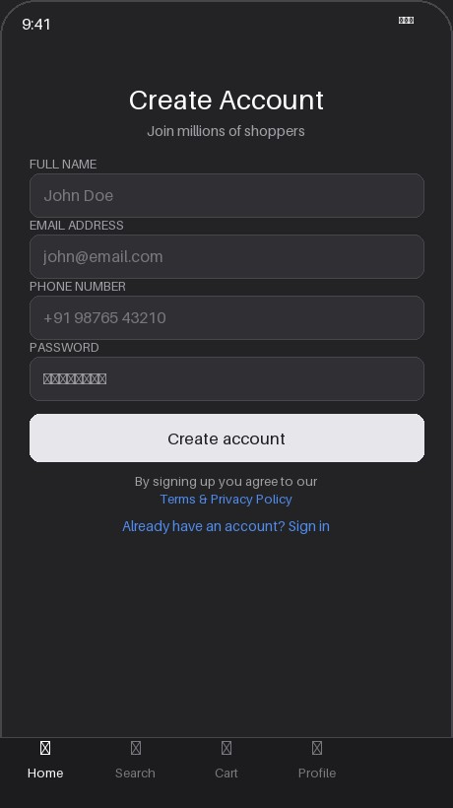
Screen 1 — Sign In Screen 2 — Register

Flow 2: Product Browse & Search

Users discover products through the home screen with promotions and curated grids, and a dynamic search

results screen with filtering and sorting.

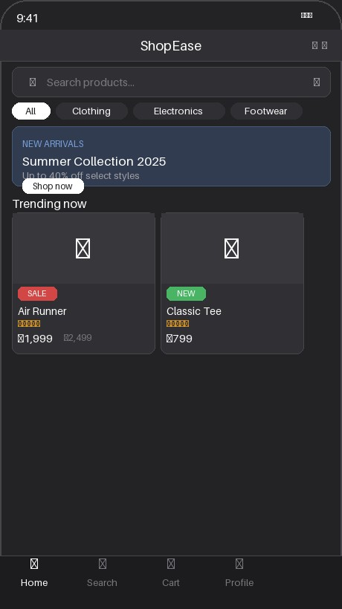
Screen 3 — Home / Browse

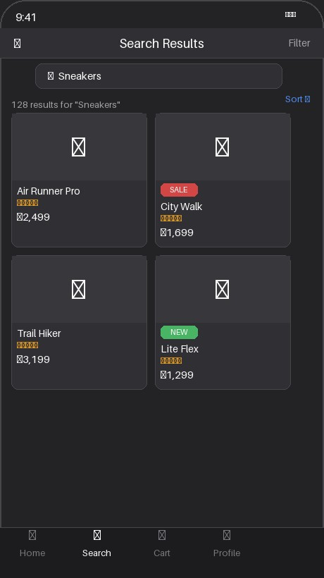
Screen 4 — Search Results

Flow 3: Product Detail & Add to Cart

Users view full product info, select size/variant, and manage their cart before proceeding to checkout.

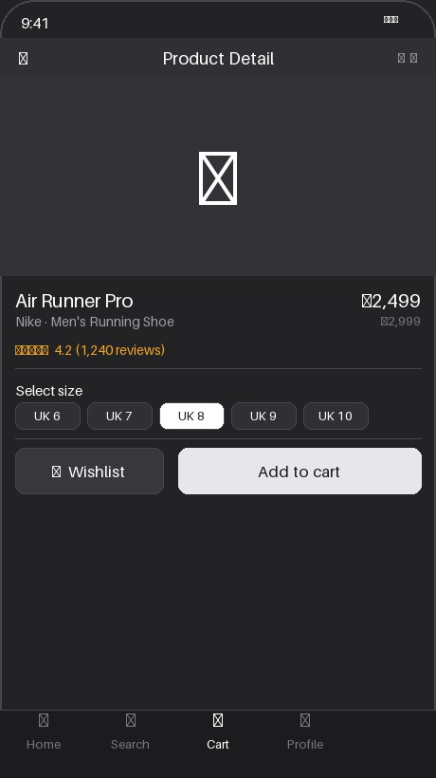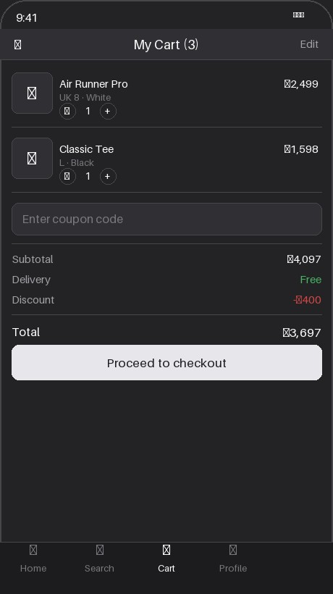
Screen 5 — Product Detail Screen 6 — Cart

Flow 4: Checkout & Payment

Two-step checkout process: delivery address selection followed by payment method selection. A 3-step progress bar guides the user throughout.

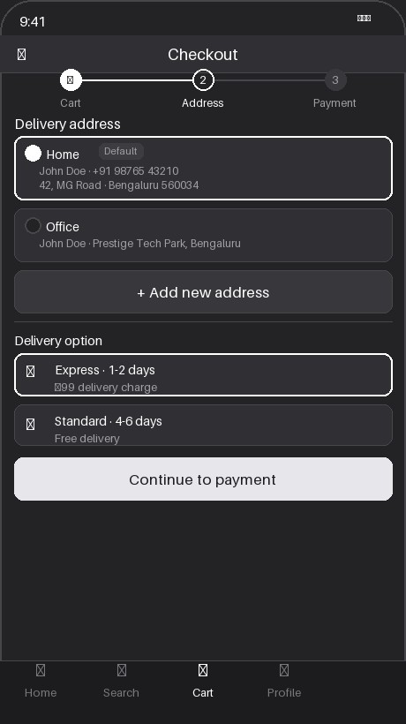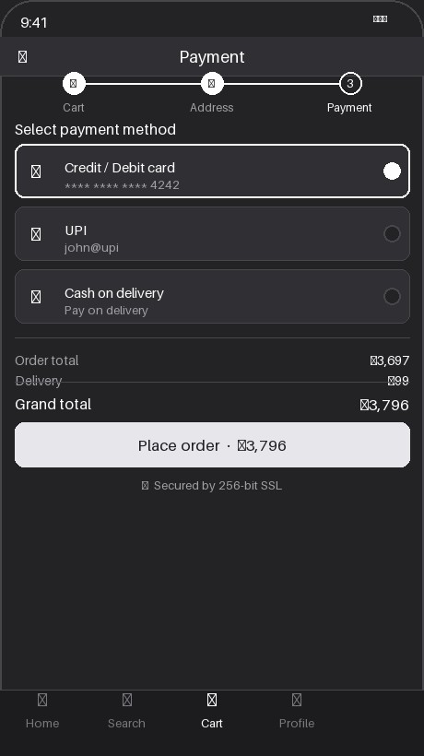
Screen 7 — Delivery Address Screen 8 — Payment
.

Flow 5: Order Confirmation & Tracking
Post-payment experience — a success screen confirms the order, and the tracking screen shows the live

shipment timeline from placement to delivery.

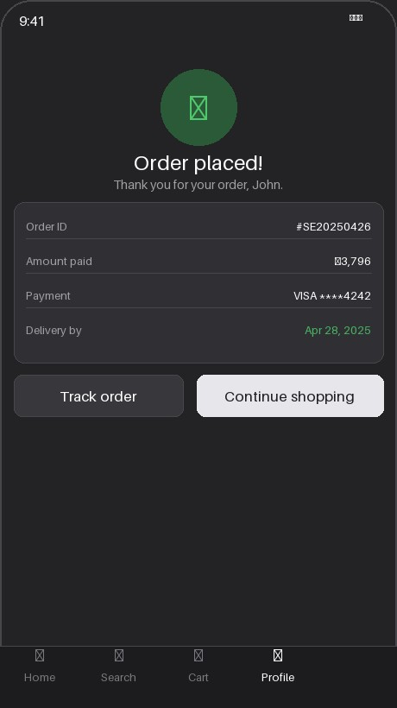
Screen 9 — Order Confirmation

All Screens Summary

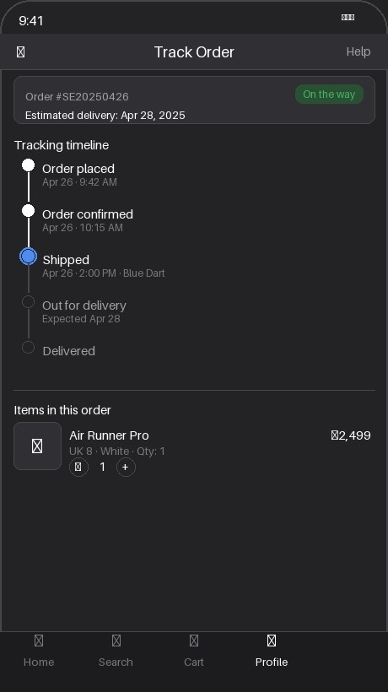
Screen 10 — Order Tracking

# | Screen Name | Flow | Key Action
1 | Sign In | Registration & Login | User authenticates
2 | Create Account | Registration & Login | New user registers
3 | Home / Browse | Browse & Search | Product discovery
4 | Search Results | Browse & Search | Filtered product listing
5 | Product Detail | Product Detail & Cart | View product, select size
6 | Cart | Product Detail & Cart | Review and modify cart
7 | Delivery Address | Checkout & Payment | Select / add address
8 | Payment | Checkout & Payment | Choose method, place order
9 | Order Confirmation | Order & Tracking | View order summary
10 | Order Tracking | Order & Tracking | Live shipment timeline

